Abzal Taltenov  Doctor of Chemical Sciences, Professor  Contact Phone: +7 702 973 52 83  E-mail: abzal06@mail.ru ;  Author ID Scopus 56728614100  ORCID ID 0000-0002-0620-3816  Researcher ID in Publons | Education, Academic Degree, and Title:  In 1994, he graduated from Al-Farabi Kazakh State University with a degree in Chemistry, qualification – chemist, teacher of chemistry.  From 1994 to 1997, he studied in the full-time postgraduate program at Al-Farabi Kazakh State University and defended his Candidate of Sciences (PhD) dissertation in the specialty 02.00.14 – Chemical Kinetics and Catalysis.  In 2007, at Al-Farabi Kazakh National University, he defended his Doctor of Sciences dissertation in the specialty 02.00.15 – Catalysis.  In 2010, he was awarded the academic title of Professor.
  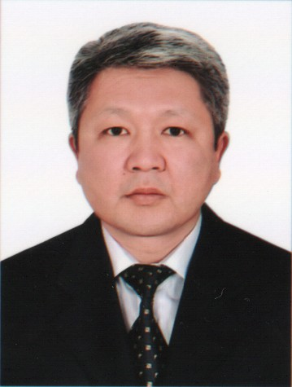
 | Research Interests: chemistry, catalysis, environmental protection and sustainability
Research Grants under Applied Research Programs:
AP26100713 – Fundamental principles for developing sustainable asphalt concrete pavements using secondary polymers and lignin to address environmental and infrastructural challenges (2025–2027).
Professional Activity:  He has 27 years of professional experience. His career began in 1998 at the Republican Scientific and Practical Center “Daryn” of the Ministry of Education and Science of the Republic of Kazakhstan, where he worked as a chief specialist and later as Deputy Director (1998–2001). From 2001 to 2002, he served as Head of the Office and Personnel Management Department at S. Toraighyrov Pavlodar State University. From 2002 to 2003, he headed the Administrative Department of the same university. In 2003–2004, he worked as Vice-Rector for Research and International Relations at S. Toraighyrov Pavlodar State University. From 2004 to 2008, he held the position of First Vice-Rector at the same institution.  From 2008 to 2011, he served as First Vice-Rector – Vice-Rector for Academic Affairs at the Semipalatinsk State Pedagogical Institute. In 2011–2012, he headed the Office of the Eurasian National University named after L.N. Gumilyov. From 2012 to 2014, he served as Vice-Rector for Academic Affairs at L.N. Gumilyov Eurasian National University, and from 2014 to 2016 – as Vice-Rector for Research. From 2016 to 2019, he was Rector of Kh. Dosmukhamedov Atyrau State University. From 2019 to 2022, he served as Director of “EFKO Almaty” LLP (an oilseed processing plant). Since 2022, he has been Adviser to the Chairman of the Board – Rector of L.N. Gumilyov Eurasian National University on Academic and Research Affairs. | Additional Information:  Corresponding Member of the International Academy of Sciences of Pedagogical Education and Academician of the Academy of Pedagogical Sciences of Kazakhstan (2009)  Academician of the Academy of Natural Sciences of the Republic of Kazakhstan (2015)  Corresponding Member of the Academy of Higher School of the Republic of Kazakhstan (2017)
Publications:
The list of works includes more than 100 publications, including 4 monographs and 7 authorship certificates.
1. Korolkov I.V., Taltenov A.A., Mashentseva A.A., Güven O. Oxidation with hydrogen peroxide as an effective method for increasing the reactivity of PET track membranes in photo-initiated polymerization reactions. Bulletin of KazNU. Chemical Series, 2015, No. 4(80), pp. 30–38. http://dx.doi.org/10.15328/cb624
2. Ilya V. Korolkov, Anastassiya A. Mashentseva, Olgun Güven, Abzal A. Taltenov. UV-induced graft polymerization of acrylic acid in the sub-micronchannels of oxidized PET track-etched membrane. Physics Research Section B: Beam Interactions with Materials and Atoms. Volume 365, Part A, 15 December 2015, Pages 419-423. https://doi.org/10.1016/j.nimb.2015.07.057
3. Ilya V. Korolkov, Anastassiya A. Mashentseva, Olgun Güven, Maxim V. Zdorovets, Abzal A. Taltenov. Enhancing hydrophilicity and water permeability of PET track-etched membranes by advanced oxidation process. Nuclear Instruments and Methods in Physics Research Section B: Beam Interactions with Materials and Atoms. Volume 365, Part B, 15 December 2015, Pages 651-655. https://doi.org/10.1016/j.nimb.2015.10.031
4. G.Shambilova, E.A. Pavlyuchkova, V.A. Govorov, I.V. Gumennyi, A.A. Taltenov, A.Ya. Malkin. Rheology of Polysulfone and Its Solutions. Polymer Science, Ser. A, Maik nauka/interperiodica /SPRINGER, 233 Spring st, New York, NY 10013-1578 USA, 2019, Vol. 61, No. 2, PP. 208–214. ISSN 1555-6107. DOI: 10.1134/S0965545X19020111. Q 3 (цитир. 4).

